**Project Design Phase-II**

**Data Flow Diagram & User Stories**

|  |  |
| --- | --- |
| Date | 26-05-2025 |
| Team ID | - |
| Team Members | Yuvraj and Amrutansh |
| Project Name | SocialeX |
| Maximum Marks | 4 Marks |

**Data Flow Diagrams:**

A **Data Flow Diagram (DFD)** illustrates how data moves within the SocialeX platform.

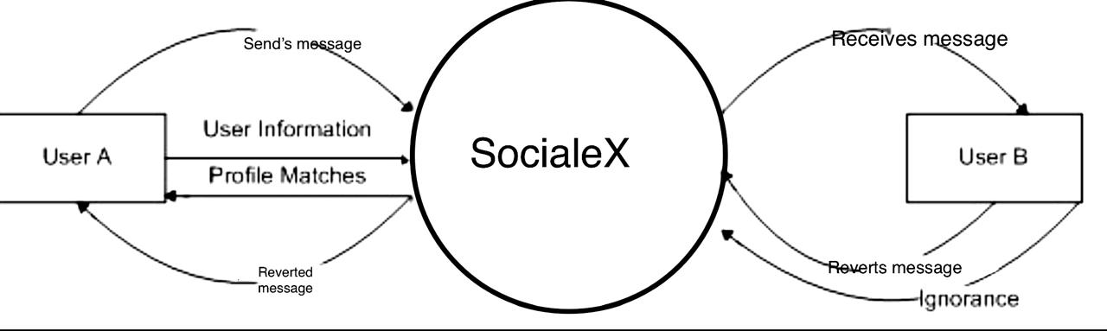

DFD level 01 Driagram

